

|  |  |  |  |  |  |  |  |
| --- | --- | --- | --- | --- | --- | --- | --- |
|  | | | | | | | |
|  | Augmented Reality with Planar Homographies | | | | | |  |
|  |  | | | | |  | |
|  | | |  |  | | | |
|  | | | Utsav Anantbhat |  | | | |
|  | | | 3/16/2023 |  | | | |
|  | |  | | |  | | |

4.1. Feature Detection, Description, and Matching:

As described in the task, the images were converted to grayscale with the “rgb2gray” function in MATLAB before the computations. The following images were visualized with different ratio values and both BRIEF descriptors and SURF features:

Ratio = 0.65 (BRIEF)

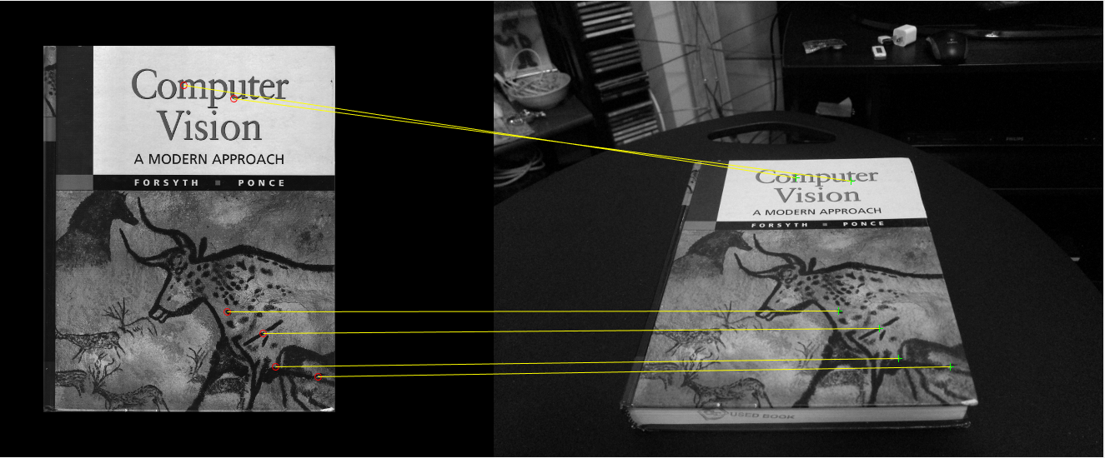

Ratio = 0.9 (BRIEF)

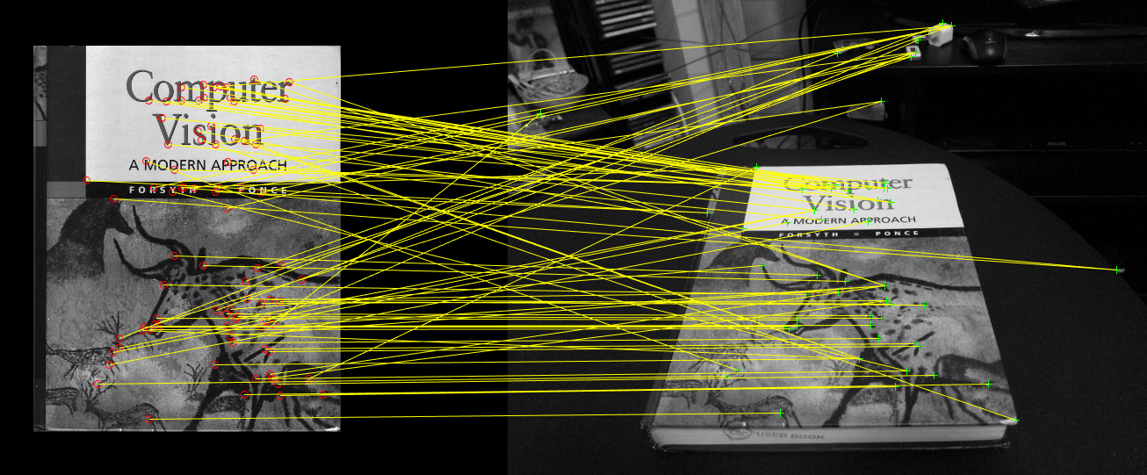

Ratio = 0.65 (SURF)

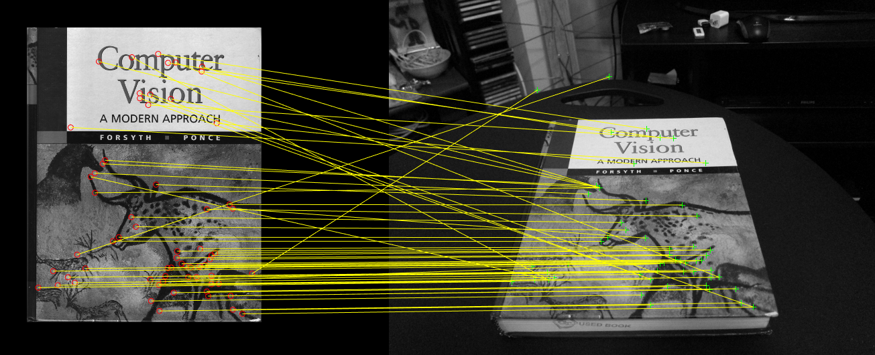

Ratio = 0.9 (SURF)

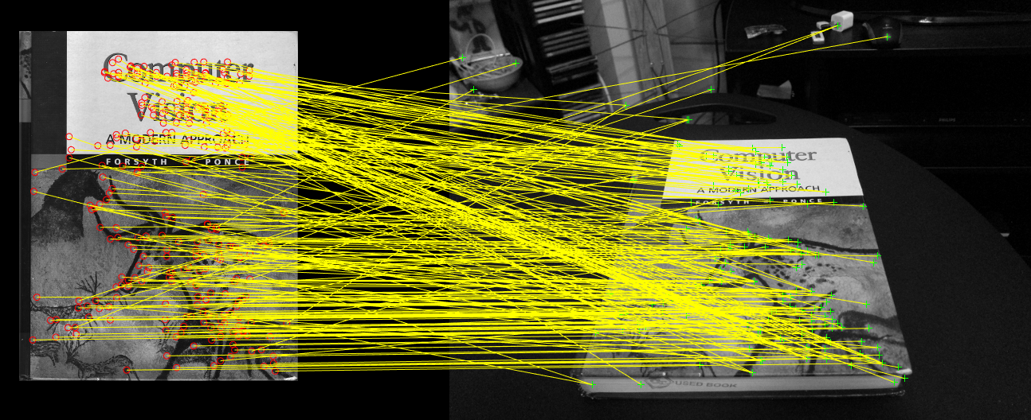

4.2. BRIEF and Rotations:

Here we took the cover image, rotated it in increments of 10 degrees up to 360 degrees, counted the number of matches (using BRIEF) for each orientation, and plotted a histogram:

Ratio = 0.9

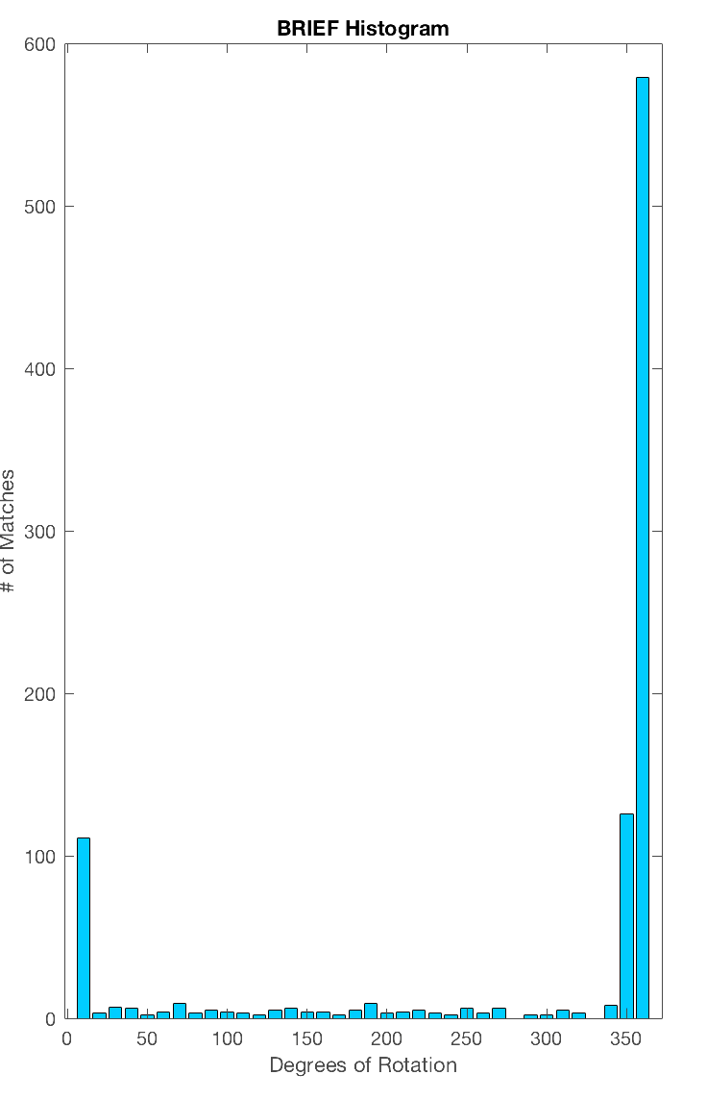

We do the same for SURF with the same ratio:

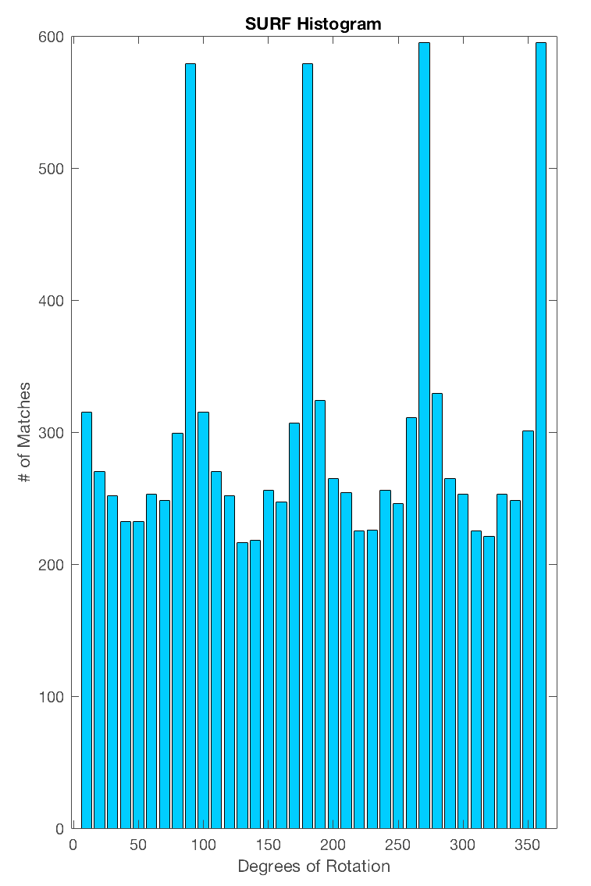

We can observe from the plots here that SURF gets better matches than BRIEF. This is because SURF considers the rotation of the image, unlike BRIEF which depends on the orientation of the image.

The following images are visualizations of the cover image at 3 different orientation for both BRIEF and SURF:

BRIEF (ratio = 0.65 for clarity):

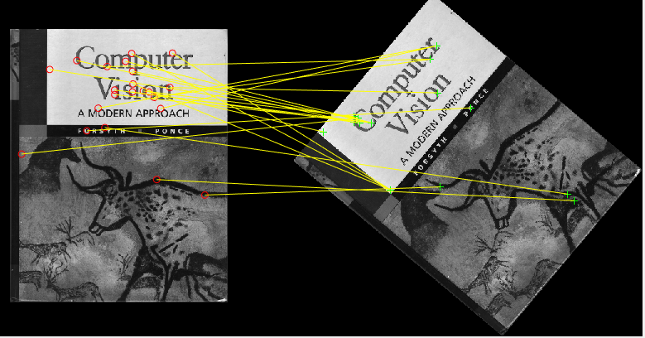

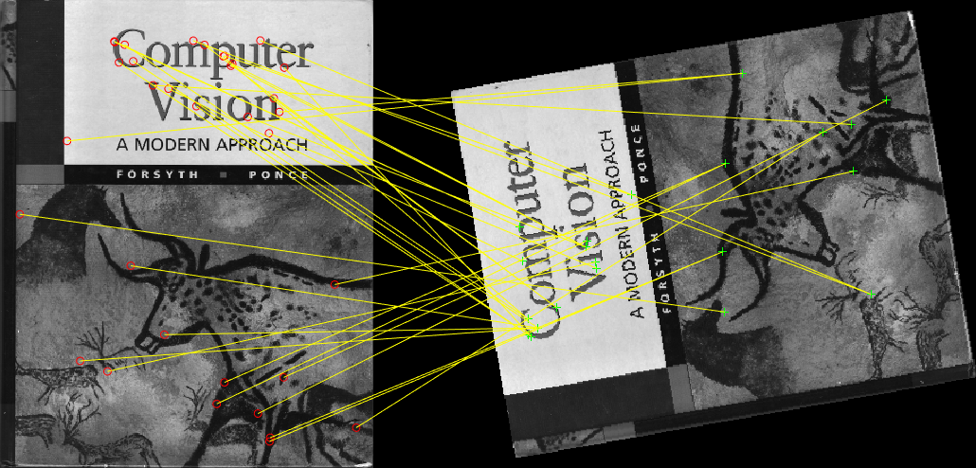

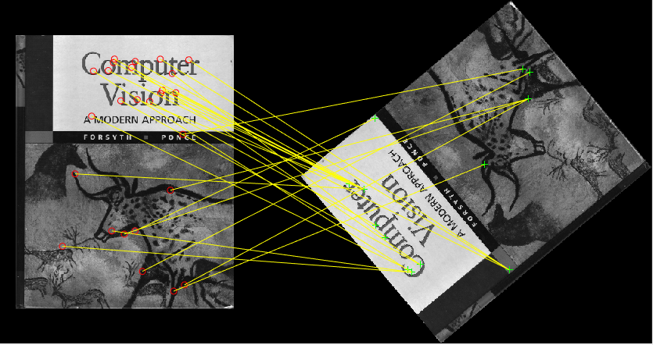

SURF (ratio = 0.65):

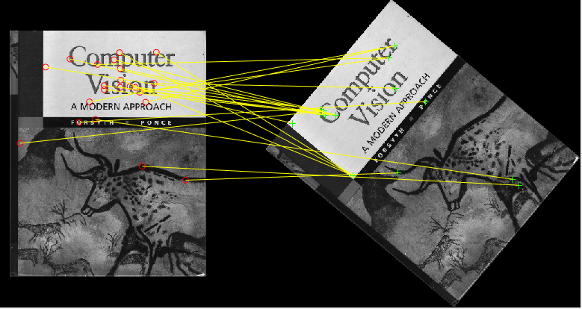

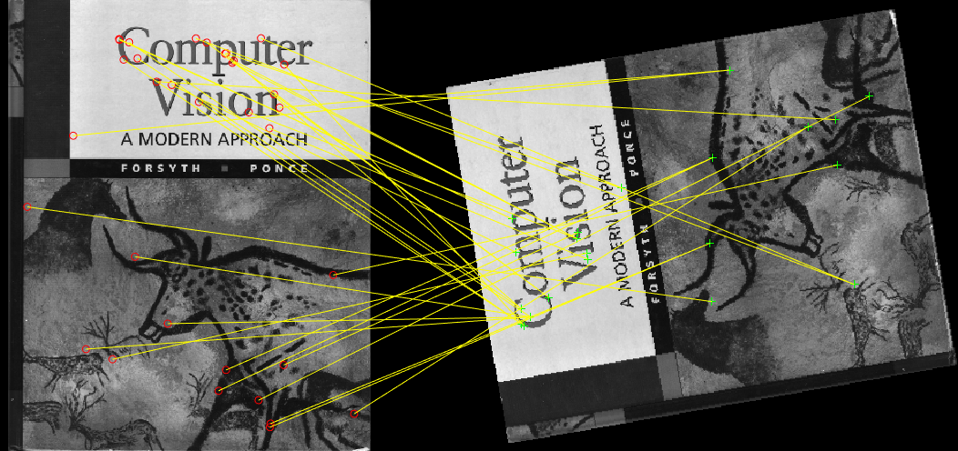

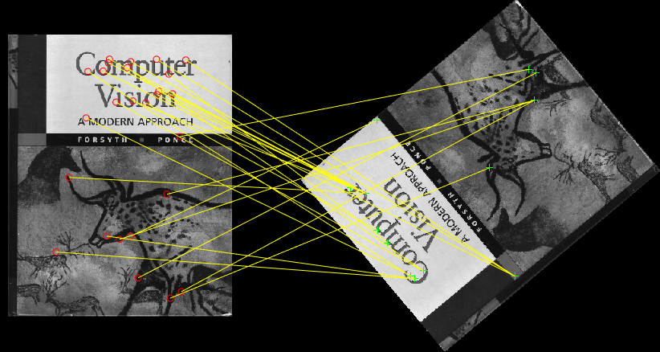

SURF has much higher matches as seen above. Upon setting the ratio to 0.9, we get a significantly higher number of matches:

BRIEF:

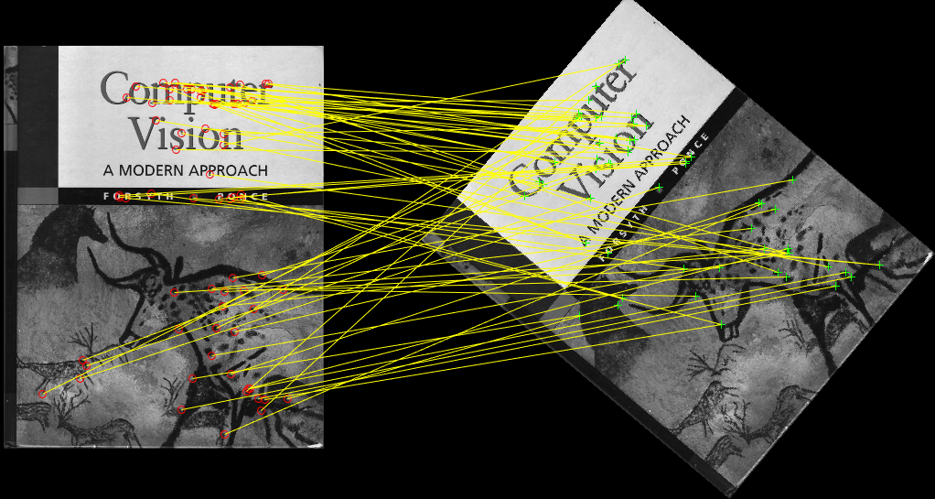

SURF:

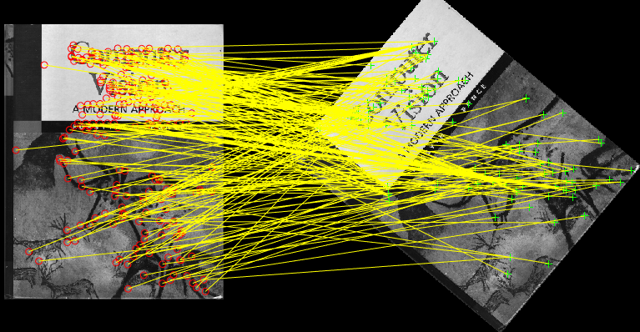

4.3. Homography Computation:

Here we compute the homography with the SVD (Singular Value Decomposition) method. SVD takes a matrix and factorizes it into three matrices. We have taken 10 random points from the N x 2 matrices containing the coordinates (x, y) of point pairs between the two images, cv_cover and cv_desk. The following is a visualization of the computation:

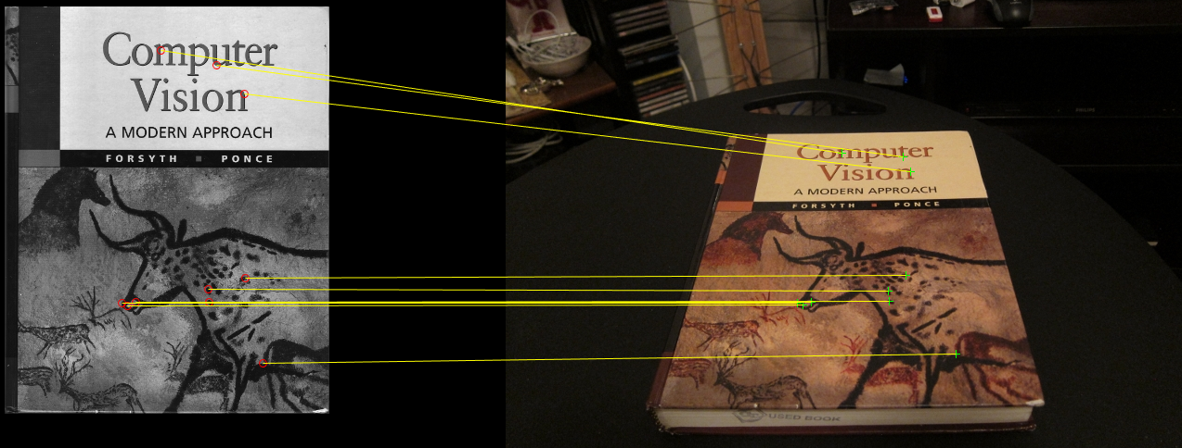

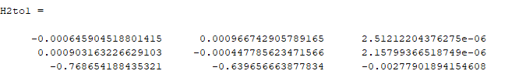

4.4. Homography Normalization:

Here we take another set of random matched pairs of coordinates and normalize them to improve numerical stability. The following is a visualization of the normalized coordinates:

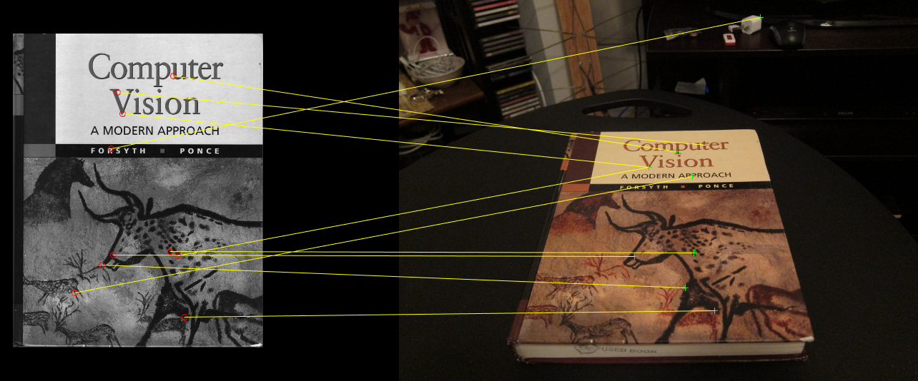

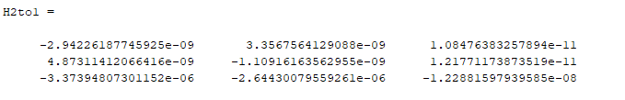

4.5. RANSAC:

Here we use the RANSAC algorithm to deal with noisiness. We set the number of iterations to 100,000 for greater accuracy. The threshold distance was set to 1 for greater precision for the transformation. The following is the visualization of the cv_cover and cv_desk images using 4 random point-pairs:

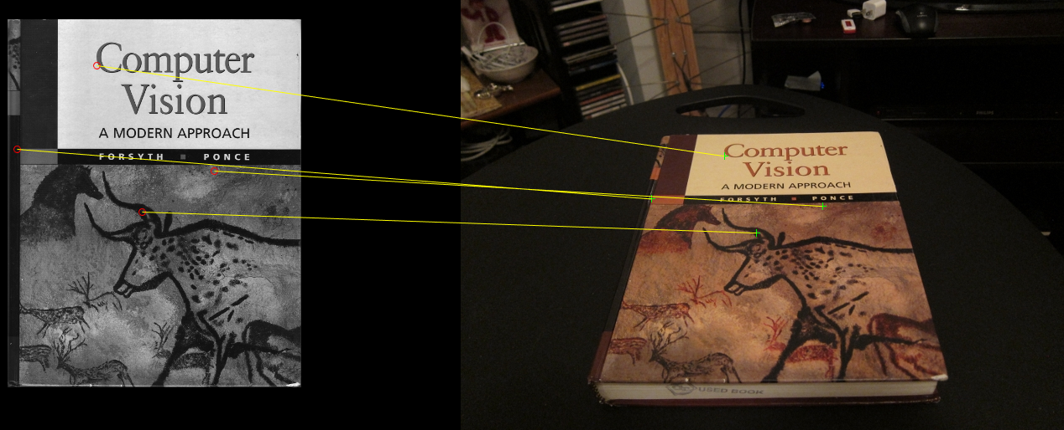

In order to test accuracy, we can increase the number of random point-pairs:

10 point-pairs:

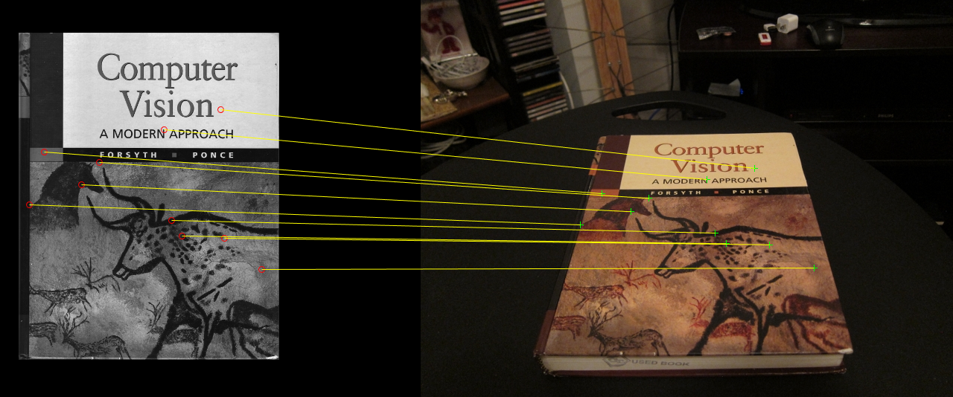

N = length of locs1/2 = 86 point-pairs:

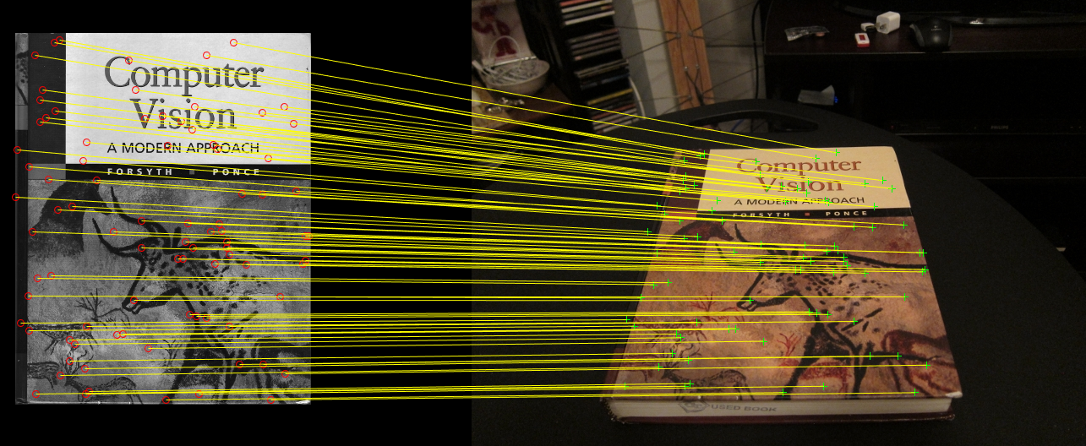

From the visualizations above, it can be determined that RANSAC is very accurate when it comes to matching points.

4.6. Harry-Potterizing a Book

Here, we used the RANSAC algorithm once again to superimpose the cover of a Harry Potter book on the cover of the cv_desk image. This was done by acquiring the size of the cv_desk image and creating a mask of the same size. The Harry Potter cover is then warped to fit the cv book cover with modifications to the given template functions. The result is as follows:

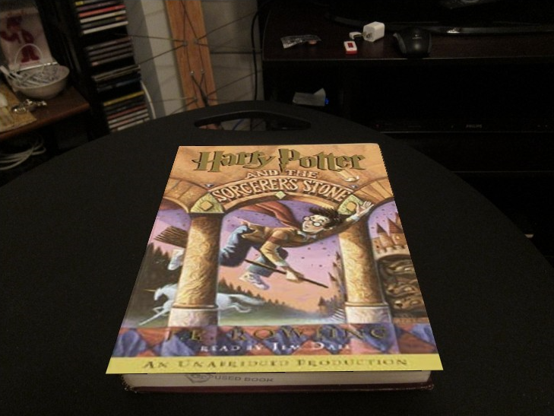

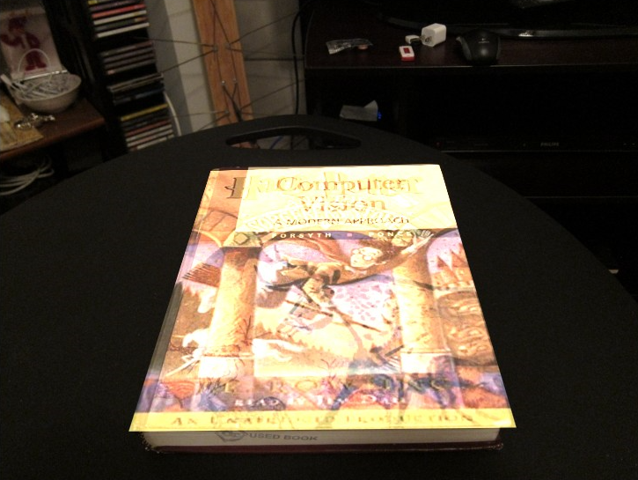

5. Creating your Augmented Reality Application

This is similar to the previous part; except we superimpose a movie to a panning book video. We take the movie source and overlay it, frame by frame, to the book video. As explained in the handout, we did so by tracking the computer vision textbook in each frame of book.mov, and overlaying each frame of ar_source.mov onto the book in book.mov. The result can be found in the zipped file. Here are some stills:

